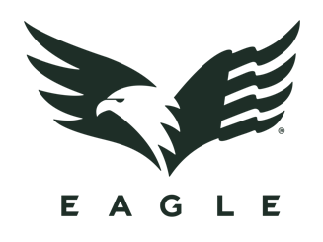

Contact: Jake Edson
Communications Manager
Outdoor Products
(763) 323-3865
E-mail: pressroom@vistaoutdoor.com
FOR IMMEDIATE RELEASE

Eagle Industries Announces All-New eCommerce Site
VIRGINIA BEACH, Virginia – July 9, 2019 – Eagle Industries, a leader in the military equipment arena for more than 30 years, has launched an eCommerce website to bring its top-of-the-line gear to discerning users in all walks of life.
“Eagle has been outfitting top-tier military units around the world with the very best gear for decades, and now we’re excited to be bringing our uncompromising products to the commercial market through this new website,” said Josh Waldron, President of Eagle Industries.
Current and former members of the military and law enforcement, as well as dedicated adventurers and connoisseurs of fine gear, will enjoy the made-in-the-USA craftsmanship, durability, and attention to detail that can only be achieved through years of tried-and-true testing by America’s most demanding users. For the first 48 hours after the website is launched at 8:00 AM EST on Tuesday, July 9, all purchases will also enjoy a 25% discount. Current and former military and law enforcement personnel will continue to receive a 10% discount even after the 48-hour sale ends.
Product offerings include everything from carriers and rigs, to packs, bags, pouches, and more. In true Eagle Industries fashion, large custom orders can be inquired about through the online form found at www.eagleindustries.com/contact-us/.
To visit the all-new website and view the full catalog of commercially-available products, go to eagleindustries.com.

About Eagle Industries
Eagle Industries was born from the uncompromising demands of the Navy SEAL community, and those standards are still what drive everything we do to this day. All of our gear is Berry Compliant and proudly made in the USA to ensure our end users – from top-tier military, to backcountry adventurers – have exactly what they need to go above and beyond every day.

